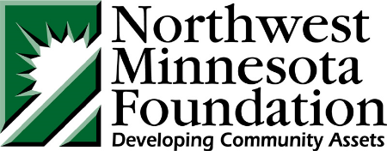
Component Fund Communications Press Kit

The Northwest Minnesota Foundation invests resources, facilitates collaborations and promotes philanthropy to make the region a better place to live and work.
We could not fulfill our mission without the work of our community and component funds.
There are several reasons component funds are established:
- Professional investment management. Gain access to our large investment pool with its high-performing assets and low investment fees.
- Relief from administrative burdens. We handle all accounting, reporting and legal requirements.
- Philanthropic training and technical services support. Our staff provides fundraising ideas, grant making, planned giving tools and support, including assisting you in structuring, accepting and managing complicated gifts.
Fund advisors should note that component funds operate under the NMF’s 501c3 status. There are requirements we insist our component funds follow to ensure our 501c3 status is not compromised.

Our logo and the following language must be included in printed material and any NMF fund websites:
“YOUR FUND NAME is a component fund of the Northwest Minnesota Foundation which (include supports language or purpose of fund). The Northwest Minnesota Foundation is a public, charitable foundation serving 12 counties of Northwest Minnesota by investing resources, facilitating collaboration and promoting philanthropy.”
A template for a press release and our NMF logo are available for download on the NMF website under news – press kit: https://www.nwmf.org/press-kit/
All publications/advertisements/press releases must be approved by your development officer before printed or published. Press Releases should be sent through our media publication list via your development officer.

